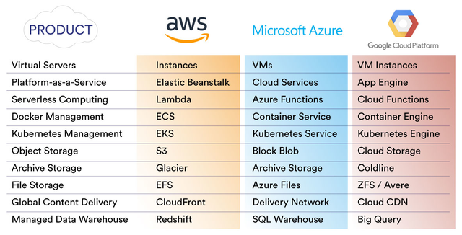

Any comparison of AWS vs Azure vs Google should be treated with caution as the cloud computing landscape changes so quickly. However, a comparison can help businesses select the best products and services from each provider in order to develop a more cost-efficient multi-cloud environment.

Our comparison of AWS vs Azure vs Google focuses on three important factors—cost, product range, and vision for the future. Of the three, cost is the driving factor for most businesses—the opportunity for pay-as-you-go computing being a huge financial benefit compared against the investment required to develop on-prem data centers.

When there is negligible difference in cost, each cloud service provider´s product range becomes the next influencing factor. Although—similar to the cost factor—product ranges change frequently. Making the most stable of the three factors in our AWS vs Azure vs Google comparison is each cloud service provider´s vision for the future.

Incorporating a “vision for the future” into a comparison of AWS vs Azure vs Google helps businesses better understand the direction(s) cloud service providers will take in both the short-term and the long-term. This better understanding will enable businesses to make better-informed decisions about what products to subscribe to and possibly influence their own vision for the future.

A comparison of AWS vs Azure vs Google costs

There is a reason we don’t often produce blogs comparing AWS vs Azure vs Google costs—price cuts. Around this time last year, we wrote about [**Amazon´s 61st price reduction**](https://www.cloudhealthtech.com/blog/amazon-prices-drop-again). Azure and Google both responded and, in March this year, we calculated [**Google is cheaper than AWS**](https://www.cloudhealthtech.com/blog/comparing-aws-vs-google-cloud-pricing) in most use cases once Google´s Sustained Use discounts, Inferred Instances, and Custom Instances are taken into account.

We also conducted an [**Azure vs AWS comparison**](https://www.cloudhealthtech.com/blog/azure-vs-aws-comparison-azure-really-catching). Although the comparison primarily related to the market size of each company, we found “on pricing alone, there are areas in which AWS is better than Azure”. So, does this mean Google is the winner in a comparison of AWS vs Azure vs Google costs? Unfortunately, it is not that straightforward.

Generally speaking, AWS tends to be the most competitive cloud service provider on a CPU/Hour basis for most workloads, whereas Google is the less expensive option for compute-intensive workloads. Azure comes into the equation if your business uses a range of Microsoft products that would qualify for a discount under an Enterprise Agreement.

The frequently-changing variety of discounts further complicates a comparison of AWS vs Azure vs Google costs. For example, six months ago, AWS introduced one-year Convertible RIs. Within ten days, Microsoft launched Azure Reserved VM Instances with free exchanges or adjusted refunds. Not to be outdone, a week later Google slashed the price of GPUs by 36% and preemptible local SSDs by 40%.

AWS vs Azure vs Google product comparison

Comparing products is a little simpler because the three Cloud Service Providers offer a very similar range. If one launches a new product ahead of its competitors, you can be almost certain the other two will release a similar product within a short space of time. What is more important in an AWS vs Azure vs Google product comparison is how the products interact with each other.

Take serverless Function-as-a-Service as an example. All three Cloud Service Providers offer serverless computing, but being able to execute functions in response to events is only as useful as what you can actually do within the execution pipeline. This is where the services differ — their ability to pass data to backend services, perform calculations, transform data, store results, and quickly retrieve data.

AWS benefits from being the leader in this area of cloud computing due to the sheer size of its product portfolio and the range of products that can be integrated using Lambda. Azure Functions is a close second, but Google is quite a way behind the market leaders in this respect—focusing more on machine learning and Kubernetes. Elsewhere, the major difference between products is the names given to them:

The visions of AWS vs Azure vs Google for the future

Speaking with the Seattle Times last November, Andy Jassy—CEO of AWS—said the company aiming on having Regions in every Tier 1 country around the world and was investing heavily in the future of AI. He promised more than one thousand “significant services or features” were going to be launched this year, with many of the new services “moving up the stack.”

Microsoft has already announced its intention to be the leader in hybrid innovations with the release of Azure Stack. Along with the Azure public cloud, Azure Sphere, and Azure IoT Edge, Azure Stack will complete the four pillars of “the world´s computer” according to Microsoft CEO Satya Nadella, who explained his vision for the future at last month’s Build 2018 event.

At the Google Cloud Platform Developer conference in March, Alphabet Chairman Eric Schmidt revealed his vision for Zero-Dev-Ops computing, in which “instead of programming a computer you teach it what it [Google’s cloud] wants to know and it learns to give you what you want.” Google also invested more than $10 billion in capital equipment last year towards the development of a serverless secure cloud.

Therefore, with minimal differences in prices and products, the determining factor in a choice between AWS, Azure, and Google could be where each is headed. Businesses with an international presence may be swayed by AWS´ promise of near-zero latency, those moving towards a hybrid environment may be tempted by the Azure vision, and those attracted by advance AI may have a preference for Google.

Simplifying the management of multicloud environments

The most likely outcome is that, rather than select the products offered by just one cloud service provider, business will pick and choose from multiple providers. Multi-cloud definitely appears the way to go, and if you want to dive deep into the multi-cloud start by asking yourself

1. What is multicloud (and why choose it)?
2. What’s the difference between hybrid cloud and multi-cloud?
3. What are the top benefits and challenges of multi-cloud?
4. What’s the right mix of public and private cloud?
5. What is a multicloud strategy?
6. How do I migrate data to the cloud to reduce IT spend?
7. What’s the value proposition of multi-cloud management?
8. How can I be confident in the performance and reliability of multi-cloud?
9. How does multi cloud-management save me time and money?
10. How should I think about security in the multicloud?

There are significant advantages for adopting a multicloud strategy. These come with challenges that don’t necessarily have to be a trade-off if they are managed correctly, and our solution is to implement a multi-cloud management platform with which you can overcome the complexities of multiple public clouds, control costs, and enforce security best practices.

The decision to “go multicloud” involves a tailored approach to cloud transformation and migration in order to align infrastructure to business needs. What it has in its favor is that it enables businesses to pick and choose the products and services that bridge any gaps between the current and ideal states—effectively eliminating the need for an AWS vs Azure vs Google comparison.